//---------------------------------------------------------------------------

#include <vcl.h>

#include <math.h>

#pragma hdrstop

#include "Unit1.h"

//---------------------------------------------------------------------------

#pragma package(smart_init)

#pragma resource "*.dfm"

int i, j;

TForm1 *Form1;

//---------------------------------------------------------------------------

__fastcall TForm1::TForm1(TComponent* Owner)

: TForm(Owner)

{

}

//---------------------------------------------------------------------------

void __fastcall TForm1::Button1Click(TObject *Sender)

{

int Tx=StrToInt(Edit1->Text);

int Ty=StrToInt(Edit2->Text);

int x = Image1->Height;

int y = Image1->Width;

for(i=0;i<=x;i++)

{

for(j=0;j<=y;j++)

{

int a = i + Tx;

int b = j + Ty;

Image2->Canvas->Pixels[a][b] = Image1->Canvas->Pixels[i][j];

}

}

}

//---------------------------------------------------------------------------

void __fastcall TForm1::Button2Click(TObject *Sender)

{

int theta =StrToInt(Edit3->Text);

int x = Image1->Height;

int y = Image1->Width;

for(i=0;i<=x;i++)

{

for(j=0;j<=y;j++)

{

int a = i*cos(theta)-j*sin(theta);

int b = j*cos(theta)+i*sin(theta);

Image2->Canvas->Pixels[a][b] = Image1->Canvas->Pixels[i][j];

}

}

}

void __fastcall TForm1::Button3Click(TObject *Sender)

{

int Sx = StrToInt(Edit4->Text);

int Sy = StrToInt(Edit5->Text);

int x = Image1->Height;

int y = Image1->Width;

for(i=0;i<=x;i++)

{

for(j=0;j<=y;j++)

{

int a = i * Sx;

int b = j * Sy;

Image2->Canvas->Pixels[a][b] = Image1->Canvas->Pixels[i][j];

}

}

}

//---------------------------------------------------------------------------

**OUTPUT SCREEN:**

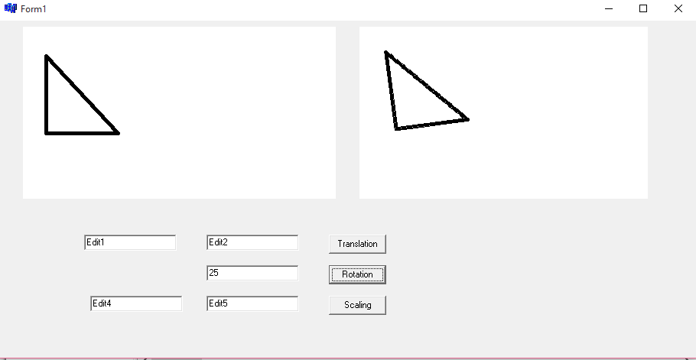

**Fig: Rotation**

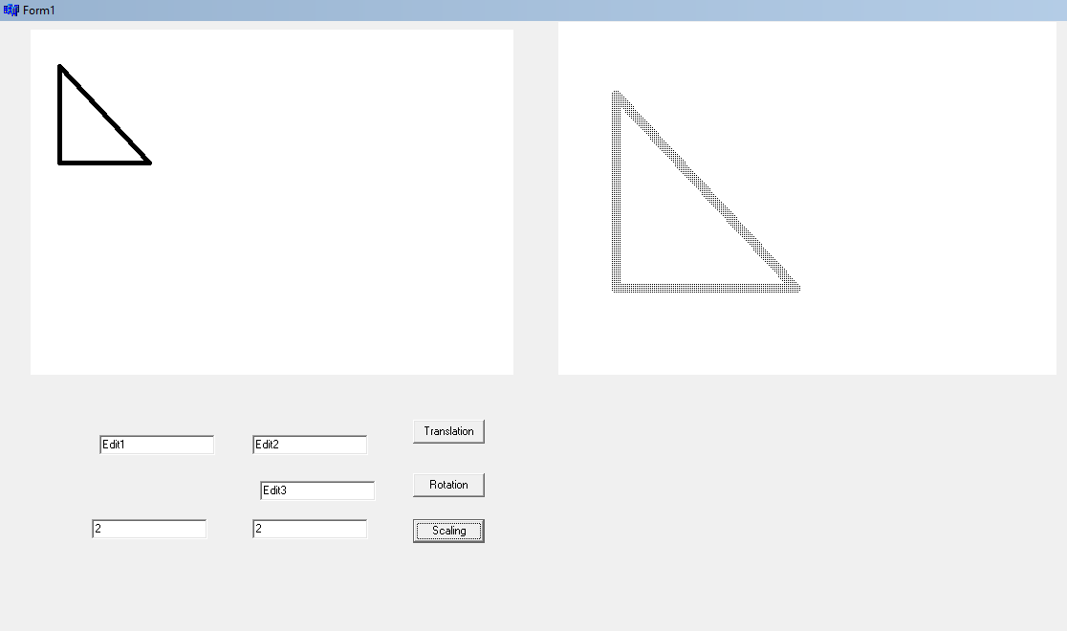

**Fig: Scaling**

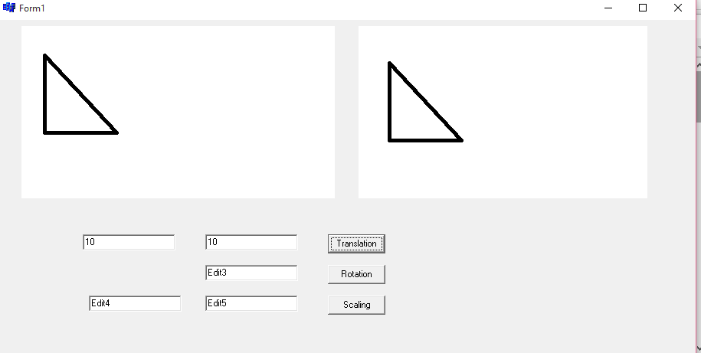

**Fig: Translation**